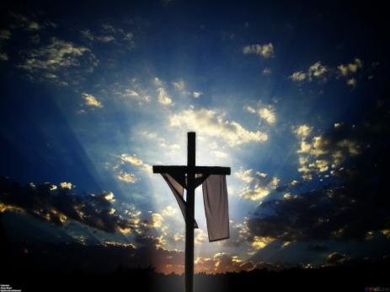
  - LAST DAYS ARMY OATH OF ENLISTMENT
  - Almighty Father, Commander of The Last Days Army, Who command is over all, and whose Love never fails, make me aware of Your Presence and obedient to Your will.
  - I, (state name of enlistee___________________________), do solemnly commit, that the start of this day, is the last day of who I was as a civilian and the first day towards being a Soldier in the Last Days Army of God. It is without force but by the will, God has given me, that has granted me the right of this irrevocable decision. As a token of my commitment and the genuineness of my decision I give You permission to enter into my life and to take charge immediately.
  - I believe Jesus Christ, the Commanding Officer, is Lord and Savior of all.
  - I believe Jesus Christ went to the Cross and rose again so I would not perish but have eternal life.
  - I confess all my sins and I receive Your forgiveness.
  - Enlist me now as a soldier in the Last Days Army of God.
  - Establish me in the boot camp immediately.
  - I will support and defend the Word of God against all enemies, foreign and domestic; that I will bear true faith and allegiance to the same; and that I will obey the orders of the Commander and Chief the Almighty Father, and the orders of the appointed officers over me, according to the will and purpose of the Lord Jesus Christ and by the Power of the Holy Spirit. So help me God.
The Last Days Church and The Coming Persecution Conference Tour – Evangelist Anita Fuentes
©Copyright EMOAF 2016

